The Funeral

Whoever comes to shroud me, do not harm
Nor question much
That subtle wreath of hair which crowns my arm;
The mystery, the sign you must not touch,
For 'tis my outward soul,
Viceroy to that, which then to heaven being gone,
Will leave this to control,
And keep these limbs, her provinces, from dissolution.
John Donne


AWD for Kathleen
c. 1986

St. John's Episcopal Church

Lancaster, Ohio
January 17, 2004
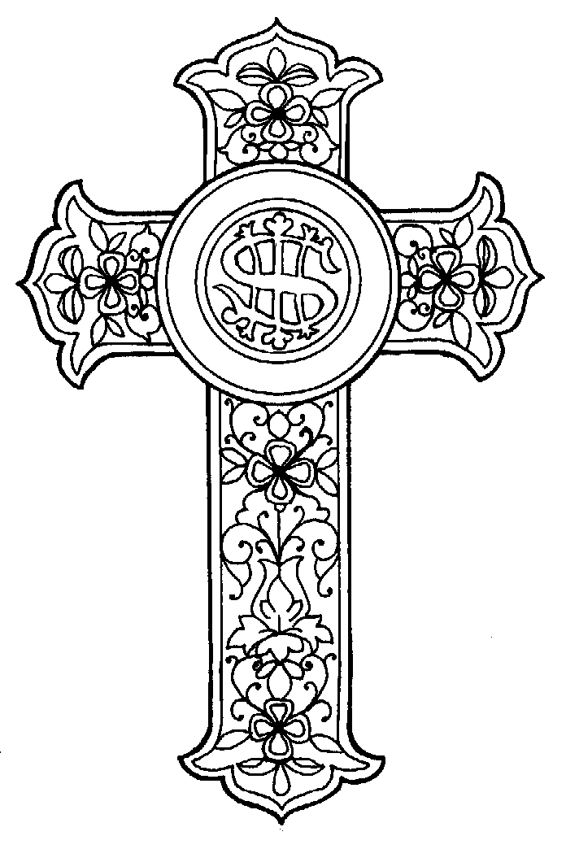

Limoges c. 1760

Gloria Deo et in Memoriam

Anthony Wyatt Davenport
June 17, 1950 – January 6, 2004

He wishes for the Cloths of Heaven
Had I the heavens' embroidered cloths
Enwrought with golden and silver light,
The blue and the dim and the dark cloths
Of night and light and the half-light,
I would spread the cloths under your feet:
But I, being poor, have only my dreams;
I have spread my dreams under your feet;
Tread softly because you tread on my dreams.

W. B. Yeats

Speakers

A reading of The Funeral by Susan Peirce for Anne Davenport
Dr. Robert Serum
Shun Endo
Bruce Altshuler
Marc Rosenthal
Bernie Nolan
David Graetz

A Celebration of Tony's Life
by Family and Friends

Opening Sentences (all stand) Prayer Book 469
Processional Hymn Hymnal 388
Collect of the Day Prayer Book 493
Old Testament Lesson (seated) Isaiah 63:1-3
Psalm 139 Prayer Book 474
New Testament Lesson Revelation 21:2-7
Psalm 23 KJV Prayer Book 376
The Gospel (stand) Matthew 11:25-30
Homily & Remembrance The Rev' d Fr. Craig Eilerman
The Apostle's Creed (stand) Prayer Book 53
Prayers of the People (kneel) Prayer Book 497

The Commendation
Solo Kyrie Trocchia-Taiganides
Pie Jesu Fauré (Requiem)
Quartet Libera me Fauré (Requiem)
Ann Trocchia-Taiganides (solo), Lisa Springer,
Mark Wagstrom (solo), Mike Springer
The Invocation & Blessing (seated) Prayer Book 482
Recessional Hymn (stand) Hymnal 688

Friends are invited to greet the family members in the Undercroft following the service.

